Free Youtube views for an unlimited number of your videos! Boost your video's popularity using their simple and free method! Or, buy Youtube views and other services here.

[ythunder.com](https://ythunder.com/) has free & open registrations.



If you want to be a ‘[YouTuber](https://ythunder.com/)’, you need to realise that it’s not going to be as easy as it looks. And it’s harder is you want to be a [YouTuber](https://ythunder.com/) because you admire big [YouTuber](https://ythunder.com/)s and wish to become like them.Free Youtube views：[ythunder.com](https://ythunder.com/)

But you surely shouldn’t let your initial nervousness get in the way of giving this powerful platform a chance. The most important thing you’ll need for a successful [YouTube](https://ythunder.com/) channel is probably something you already have – an understanding of who your audience is and what are they seeking that can be valuable to them.

If you are a small business or organisation, building great content on [YouTube](https://ythunder.com/) will help your branding and show off your business expertise. It’s a great way to connect with a market and engage with the audience.

**Tips to Grow Your** [**YouTube**](https://ythunder.com/) **Channel from Zero (**[**Youtube**](https://ythunder.com/) **SEO):**

**1. Fix your Channel Profile**

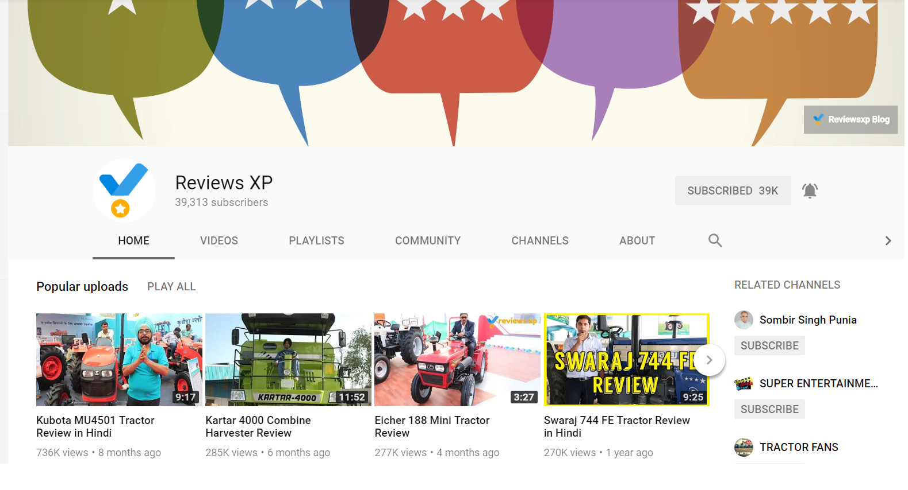Free Youtube views：[ythunder.com](https://ythunder.com/)

Life sang

First things first, perception is key so you need to make everything as attractive as possible. As shallow as that sounds, people only look at good things and if you’ve got a beautiful profile and a welcome video that engages the viewer, what have you even got to lose?

Your success and subscriber rate is closely related to how good your page looks. You need to grab the viewer’s attention.

**2. Upload a great profile and cover photo**

Make a catchy cover on websites such as Canva for free. Furthermore, make your profile something that defines you. Introduce yourself to the subscribers. Tell them things that make you interesting as well as a bit unique.

Why else would they want to subscribe? Add your social media accounts for them to explore you on various platforms.

**3. Add a Welcome Video**



We can’t emphasise how important a welcome video is. Give the audience a preview of what to expect when they subscribe to your channel.

Keep it short yet entertaining. It should be a glimpse into the content you make and also an introduction to you as a [YouTuber](https://ythunder.com/). Make sure to add an attractive description.

**4. Regular content**

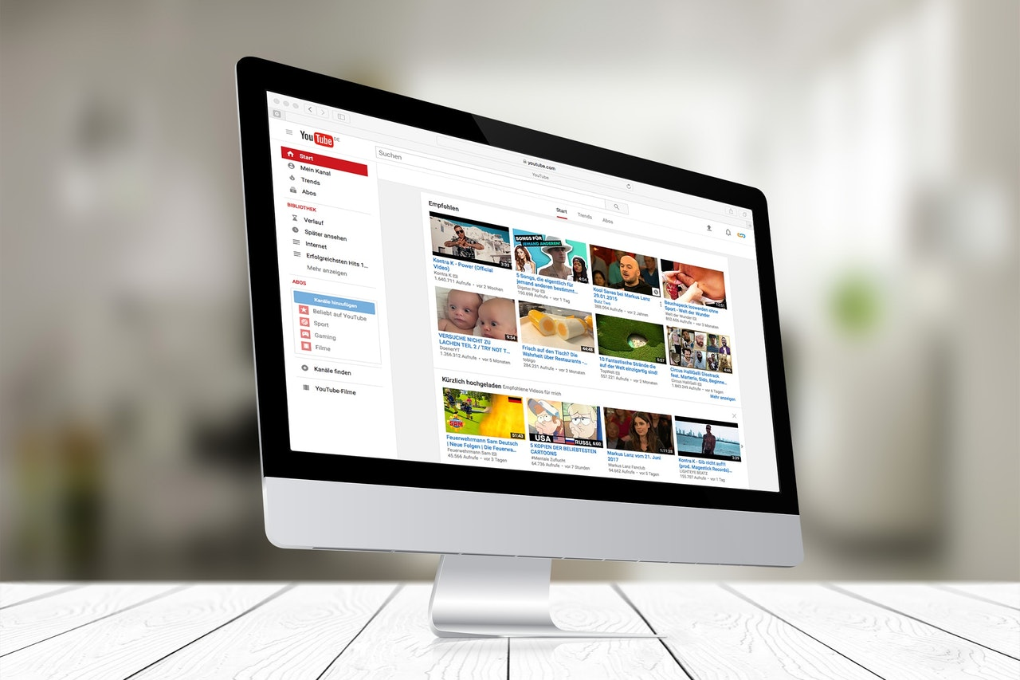

When it comes to content creation we would highly advise that you don’t start uploading immediately. Before you take the steps mentioned above, make sure that you have 5-10 videos lined up at least. This will ensure that you remain consistent in your uploading.

If you start your channel with only uploading once a week it is easy to feel stressed out about getting another video out. We suggest this to be on the safer side since it’s a very shiny world, people forget to plan ahead. They think it’ll be easy to make it as a [YouTuber](https://ythunder.com/) anyone can do it but the reality is far from what is perceived.

**5. Categorize your Channel**



To make really engaging content don’t be all over the place. Know your niche and stick to it. If you categorize your [YouTube](https://ythunder.com/) channel, it’ll be easier for you to stick to the plot. If you want to make a makeup channel, explore avenues such as various tutorials and hacks for beginners or even professionals. Try something in this niche that’s never been offered before.

Make content that sets you apart from the rest. Create special playlists and feature them on your profile page so that you give your viewers a direction as to how to go about your [YouTube](https://ythunder.com/) channel.

**6. Engage with your audience**



Pay attention to the trends. While you can be original, you can also take advantage of trending social media happenings. Merge originality to include trending topics to engage with a wider audience.

Uploading videos on a trending topic is a great trick for you to garner more attention. People can stumble upon your content on search and relate to it more.

**7. Ads and Influencer Marketing**



Being a [YouTuber](https://ythunder.com/) is all well and good but you also need to know how to make money off of [YouTube](https://ythunder.com/). Firstly, become a [YouTube](https://ythunder.com/) partner by enabling monetization on most of your videos, if not all since you can’t monetize copyrighted content.

Ad funding seems like a small avenue but it’ll be a good boost for you to stimulate your [YouTube](https://ythunder.com/) channel. The right time to start looking at influencer marketing and sponsorship opportunities is as soon as you hit 1-2K subscribers. You can promote your own business while spreading awareness for name brands through videos, sponsored reviews/overviews, and subtle plugs like using their products in your videos.

**8. Collaborate with Other** [**YouTuber**](https://ythunder.com/)**s**



Collaboration implementation and make or break your [YouTube](https://ythunder.com/) channel. If you’re smart about it, you can further your channel to greater heights. Don’t be under the misconception that bigger [YouTuber](https://ythunder.com/)s don’t need collaborations. They most definitely do. Once you’ve built a sizable amount of following, you can connect with other [YouTuber](https://ythunder.com/)s whom you genuinely admire and want to collaborate with.

The goal is to also appear in a video on their channel while you feature them in yours. It’s a mutual promotion where both of you ask your viewers to check out content made by the other person. An ideal collaboration would be if you find a harmony where you can merge the genre of both channels and create something unique. It’s a great way to make new friends and add creative minds together in building channels. Significantly, it also introduces you to a newer audience.

**9. Buying** [**YouTube Views**](https://ythunder.com/)



View count is a very important factor for viewers to determine whether your video is watchable or not. It also defines the quality of your video, however bizarre that may sound. Your videos could be amazing but with no views, it’ll fail to garner the exposure it needs. So to come up from this stagnant phase, most [YouTuber](https://ythunder.com/)s resort to buying [YouTube views](https://ythunder.com/). They’ve turned to paid views to help market their videos.

Buying views generates views for your videos through bots or more authentic methods, you choose your method. They give the impression that your video is more attractive than it actually is. People usually gravitate to the video with more views, that’s just the reality of the trade. Companies such as ythunder will help you build a fan-base for yourself by creating a social proof that your channel needs.

It’ll also ensure higher rankings and improved credibility as [YouTube](https://ythunder.com/) takes views into consideration when ranking videos. And higher rankings also mean new subscribers. Using legitimate websites such as ythunder will ensure that you get what you paid for. Make sure you check the authenticity of every website you purchase from.

If you’re looking to jumpstart your channel or add some social proof to your videos, the methods mentioned above are crucial.Free Youtube views for an unlimited number of your videos! Boost your video's popularity using their simple and free method! Or, buy Youtube views and other services here.

[ythunder.com](https://ythunder.com/) has free & open registrations.